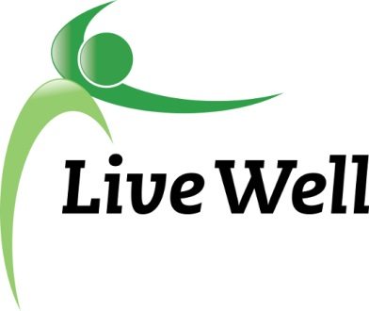
AGENDA

Healthy Food for All Work Group

Lawrence Public Library, Meeting Room A, KS 66044-3701, United States

3:00pm – 4:30pm, Wednesday, February 21st, 2017

Agenda items | Notes | Action Items
- Introductions | - Share agency accomplishment pertaining to HFFA work. Include:  - Who, what, where, when, any partners, number of participants, description
- Announcements | - Nation Builder Training  - Food Systems Leadership Network-  “Wallace Center launched a new national Community of Practice to support leaders and staff of non-profit, community-based organizations working on food systems change”  - Emergency Resources Spreadsheet-  - Work to update 211?  - Summer Feeding Program Update- Michelle
- Subcommittee Break out session (30 minutes)  Pantry: Sue, Christina, Jessica, Connie, Gwen, Liz  Corner stores: Michelle, Helen, Melissa, Kelsey, Brooke | Points of Discussion:  - Continued work on projects  - Intern projects-submit to Kelsey  - Action items moving forward-Specific assignments.
- Subcommittee report to group | Small report back on discussion and action steps
- Additional updates | - Announcements for the group  - Next meeting- 3/21, 3-4:30pm, Signs of Life Conference Room- 722 Massachusetts St, Lawrence, KS 66044
- Adjourned

